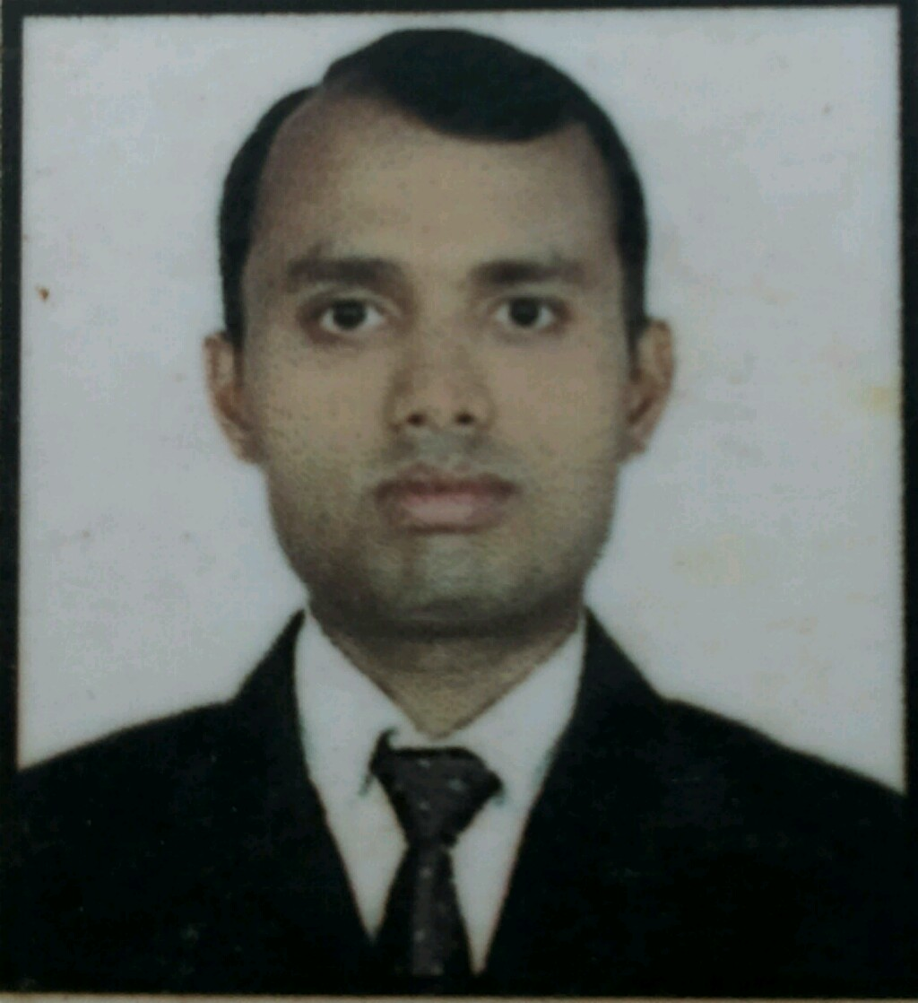
MOHAMMAD PARVEJ ALI
H no. 29, Jindal coloneycoloney
samalkhaNew delhi -110037
eMail-Parvej.632@gmail.com
Skype id- parvej.632
ph. No.+919560562024
OBJECTIVE:
To obtain an exciting and challenging position with an organization offering a rewarding career opportunity and professional growth, where I can best utilize my skills and contribute towards the growth of the organization.
Educational qualification:
I have done 10th from BSEB patna.
I have also done 10+2 from BSEB patna.
I have also done graduation from kalinga university.
EXPIREENCE:
- I have also two year experiencein shangri-la hotel new delhi from oct 10,2008 to aug 01,2010
- Persently working working with the leela hotel gurgaon delhi ncr from 1stMarch 2011 to till date.
SKILL SET:
- Housekeeping administration
- Coustomer care strategie
- Service Excellence
- Room cleaning
- Pantry cleaning
- Public area cleaning
- Problem solving
- Team management
- Minibar knowledge
AVAVIBILITY:
- Ready to relocate immediately
- Don’t have a bond with tUrduurrent employer
ACHIEVEMENTS:
- Actively participated in different activities of hhotel

PERSANAL INFORMATIO:

Father name: Md. shazeed
Date of birth: 16th August 1983
Sex: Male
Marital status: married
Nationality: Indian
Language known: English, Hindi, Urdu
Date Md. Parvej ali
Place

